**HOW TO MAKE MONEY WITH ARTIFICIAL INTELLIGENCE IN 2023**



**INTRODUCTION**

Just a few years ago, it seemed like anyone with a passion and a good work ethic could learn to program and end up making six figure money in a few years doing basic programming jobs.

However, that may no longer be the case!

Since 2022, layoffs and lack of jobs have rocked the tech industry.

Despite these setbacks, one area is booming and has become a hot topic among investors and entrepreneurs: ***artificial intelligence***.



*(Source precedenceresearch.com)*

As we move into 2023, artificial intelligence is becoming an increasingly valuable tool for entrepreneurs and business owners looking to generate income through digital platforms.

In this blog post, I’ll show you how to make money using artificial intelligence in 7 easy ways.

Whether you're a tech enthusiast, a creative professional, or just looking for new ways to earn some extra cash, there's an AI-powered opportunity waiting for you.

So if you're ready, let's get started!

How to make money with artificial intelligence: 7 easy ways

**1. BUILD AI-DRIVEN APPLICATIONS**

As artificial intelligence technology develops at an alarming rate, there is a huge demand for innovative applications that can solve real-world problems in healthcare, education, finance, and other fields.

This is a great opportunity for developers to innovate and earn tons of money by building cool AI-powered apps that businesses can use.

Many companies are starting to incorporate artificial intelligence into their products, so it's an exciting time in this field.

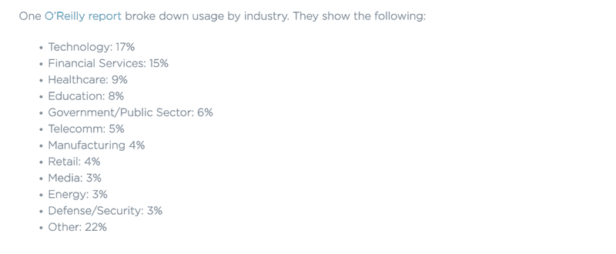

To name a few examples, AI-driven healthcare applications can assist doctors in diagnosing diseases and developing personalized treatment plans.

In education, AI can enhance students’ learning experience by providing personalized learning plans and automated feedback.

And in finance, AI-driven applications can analyze large amounts of data to identify patterns and trends to improve decision-making and reduce risk.

If you're feeling particularly ambitious, starting an AI software company might be a great way to get in on the action.

There are some venture capitalists keen to invest in emerging AI startups, so if you have a great idea, you might just hit the jackpot.

By creating AI-powered applications, you're not just making money, you're making a difference in the world.

Who knows, maybe your app will revolutionize an industry or improve people's lives in some way.

**2. SELLING AI-GENERATED CONTENT**

With advances in natural language processing, machine learning, and deep learning, artificial intelligence is now able to create content that is virtually indistinguishable from content written by humans.

AI-generated content has a variety of applications, including chatbots, product descriptions, social media posts, news articles, and even creative writing.

And as more businesses look to automate their content creation processes, the demand for AI-generated content will only increase.

You can take advantage of this trend by offering your services as an AI content generator. Or, you can even create your own AI content generation platform and license it to businesses.

And best of all, because the content is automatically generated, you can produce large amounts of high-quality content quickly and at a lower cost than traditional human-written content. This means you can make money while providing valuable content to your customers.

An example of such a platform is Content at Scale, which provides businesses across industries with AI-generated content solutions at very reasonable prices while ensuring the content passes AI detection checks.

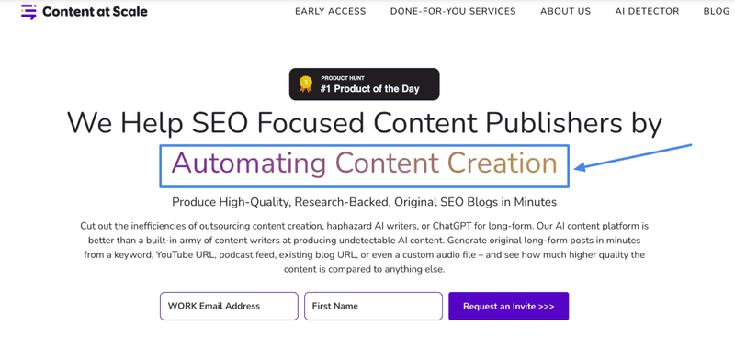

**3. PROVIDE ARTIFICIAL INTELLIGENCE CONSULTING SERVICES**

If you have a knack for artificial intelligence, then offering consulting services could be a lucrative option for you.

You can work as a freelancer, consultant, or even as an employee of a company. With the rapidly increasing demand for AI professionals, there are many opportunities to explore.

Companies are actively seeking individuals with AI expertise and are willing to pay top dollar for someone with the right skills.

As an AI consultant, you can help businesses strategize how to use AI to grow their business, whether at a commercial or engineering level.

The key is to have a strong portfolio, demonstrate your expertise, and then seek out companies that need your help.

You can find these opportunities on freelance websites or even on professional networking sites like LinkedIn or Indeed.

It's all just about selling yourself well and highlighting your skill set. With the right approach and a little effort, you can establish yourself as a popular AI consultant in no time.

**4. AI EDUCATION**

As AI becomes more popular than ever, the value of AI education is growing rapidly.

A prime example is Andrew Wu's Artificial Intelligence course on Coursera, which attracts hundreds of thousands of students around the world.



If you have a passion for teaching, there are many opportunities for you to earn some serious money.

You can start by creating helpful content, such as YouTube videos or tutorials, or even try in-person tutoring with peers.

For those feeling ambitious, organizing large workshops to teach AI to larger groups is also an option.

With the power of artificial intelligence, you can generate, content ideas, scripts, and even visual effects such as images and videos without having to show your face in front of the camera.

With someone now earning a decent income entirely from AI-generated content, the possibilities for this kind of work are endless. It is a very exciting time to be involved in AI education!

**5. AI-GENERATED ART**

AI has transformed the art industry and there are now many ways to earn income through AI art.

According to GlobeNewswire, the size of the artificial intelligence art market is expected to soar from US$7.9 billion in 2021 to US$110.8 billion in 2030. This is an amazing growth opportunity.

The good news is, you don't need to be a tech genius to take advantage of this nascent market.

Artists and creators can use online platforms and tools like DALL-E and Midjourney to create and sell AI-generated artwork. Additionally, working with artists and designers to create unique AI artworks and sell them on online marketplaces like Artsy and Saatchi Art is another viable option.

Another way to make money with AI art is to offer AI art services, such as creating custom AI-generated logos, designs, and graphics for businesses and individuals.

With the ever-increasing demand for AI art, there are endless opportunities to make a profit.

Whether you’re a professional artist, designer or entrepreneur, the world of AI art offers huge potential for creativity and income generation, and there’s no better time than now! You are good to go!

**6. CREATE AN AI-POWERED AFFILIATE MARKETING BUSINESS**

If you're looking for a way to monetize your blog or website, affiliate marketing can be a lucrative option. However, with so many affiliate products and keywords, it can be a challenge to identify the right products to promote.

This is where artificial intelligence comes into play. By using software powered by artificial intelligence, you can quickly identify high-converting keywords and create content around them. AI can also help you identify the best affiliate products to promote based on your niche and audience.

Additionally, there are AI-powered affiliate software that can take your business to the next level by tracking, analyzing, and optimizing your affiliate marketing campaigns in real-time.

One of the most popular options is Scaleo, which uses artificial intelligence technology to automate your business processes and increase your profits.

So, if you’re interested in starting an affiliate marketing business, incorporating artificial intelligence into your strategy can help you optimize your campaigns, increase conversion rates, and ultimately generate more revenue.

**7.AI STOCK TRADING**

Finally, let me introduce you to a fascinating concept that has the potential to generate huge profits - AI stock trading!

It's a fascinating concept with the potential to generate huge profits.

Did you know that predictive models powered by artificial intelligence are now so mature that if implemented correctly, they can predict market movements with over 90% accuracy?

These models can analyze large volumes of data related to a company's financial performance by examining historical data such as revenue, cash flow, and expenses.

This analysis enables the model to make predictions about market trends, helping traders make informed decisions about when to buy or sell stocks.

By using artificial intelligence to analyze data and make predictions, traders can reduce their risk and increase their chances of making a profit in their trades.

However, it is important to remember that the stock market is a highly competitive and unpredictable environment where trading algorithms are constantly evolving.

While using artificial intelligence in stock trading can give you an edge, it is still crucial to have a solid understanding of finance and the stock market.

If you are willing to put in the time and effort, AI stock trading could be a lucrative opportunity worth exploring.

**SUMMARY**

In conclusion, artificial intelligence brings many opportunities to make money in various fields.

Whether you're interested in AI stock trading, AI-generated art, or providing AI services, there's potential for profit.

However, it’s important to remember that AI is not a magic solution and requires effort, knowledge, and skill.

With the right approach and mindset, you can harness the power of artificial intelligence to achieve your financial goals.

Good luck!

**THE AUTHOR: MARK CHEN**

IC design and verification, artificial intelligence for money and finance, web development. More refer to http://plutus.eu.org